STRENGTHENING NATIONAL AND COMMUNITY SYSTEMS FOR EFFECTIVE DISASTER RISK MANAGEMENT PROJECT

PROJECT REPORT

MAY 2013 TO APRIL 2014
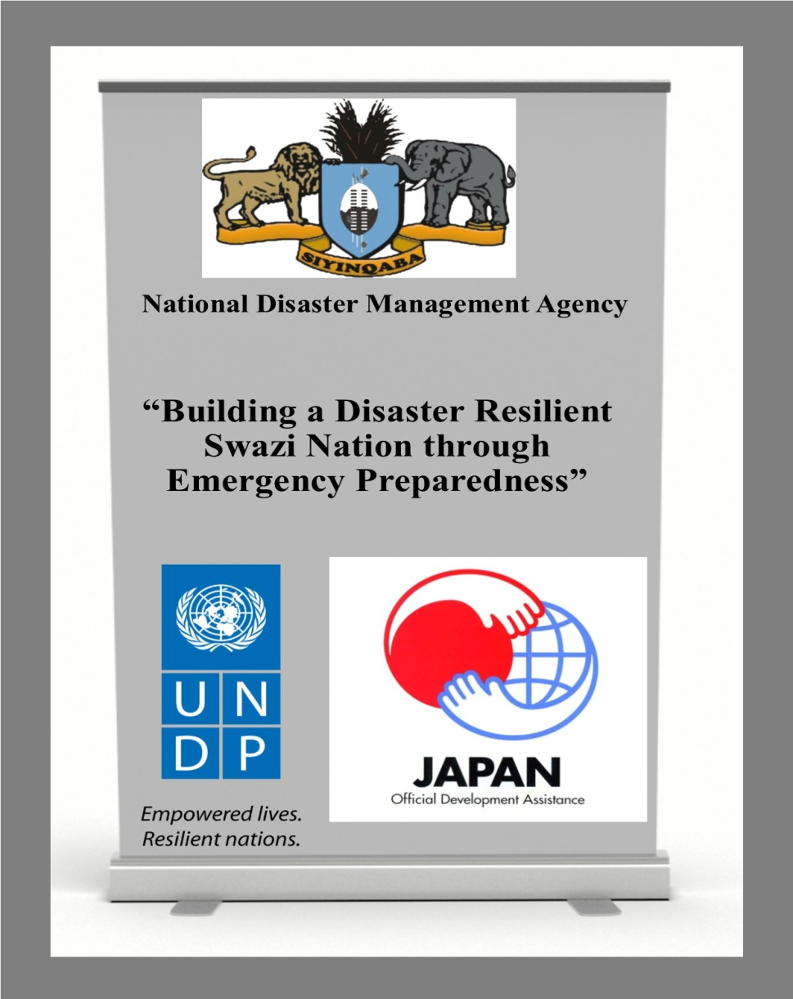
Project Title: Strengthening National and Community Systems for Effective Disaster Risk Management
Project Number: 00086885
Project Period: May 2013 to April 2014
Total Budget: USD 910,891.00
Funded: Japan International Cooperation Agency (JICA)
Implementing Partners: National Disaster Management Agency (NDMA); Ministry of Tinkhundla and Regional Development (MTRD); Urban Local Government Authorities (ULGAs); Swaziland Association for Local Government Association (SWALGA); Baphalali Swaziland Red Cross Society (BSRCS); World Vision Swaziland (WVS)

Table of Contents
1.0 Introduction and Executive Summary Error! Bookmark not defined.
2.0 Implementation Progress Error! Bookmark not defined.
3.0 Project Implementation challenges Error! Bookmark not defined.
4.0 Financial Status and Utilisation Error! Bookmark not defined.
Annex 1: Members of Project Steering Committee Error! Bookmark not defined.

Acronyms and Abbreviations

ART Anti-Retroviral Treatment
AWP Annual Work Plan
BCPR Bureau for Crisis Prevention and Recovery
BSRCS Baphalali Swaziland Red Cross Society
CCA Country Capacity Assessment
CSA Country Situation Analysis
DPMO Deputy Prime Minister’s Office
DRM Disaster Risk Management
DRR Disaster Risk Reduction
EOC Emergency Operation Centre
EPR Emergency Preparedness and Response
ER Early Recovery
EW Early Warning
EWS Early Warning System
FSE&CC Federation of Swaziland Employers and Chamber of Commerce
GDP Gross Domestic Product
INEWS Integrated National Early Warning System
JICA Japanese International Cooperation Agency
MHCP Multi Hazard Contingency Plan
MIC Mid Income Country
MSB Swedish Contingencies
MTC Matsapha Town Council
MTRD Ministry of Tinkhundla and Regional Development
NDMA National Disaster Management Agency
OCHA Office for the Coordination of Humanitarian Affairs
SHIES Swaziland Household Income & Expenditure Survey
SWALGA Swaziland Association for Local Government Authorities
ToR Terms of Reference
ULGA Urban Local Government Authorities
UNDP United Nations Development Programme
WFP World Food Programme
WVS World Vision Swaziland

1.0 Introduction and Executive Summary

1.1 Introduction
Swaziland is a small land-locked country of about 1.2 million people. Although classified as a lower middle income country (MIC), Swaziland has widespread poverty (63 percent) of approximately with 30 percent living in extreme poverty (SHIES, 2009/10), with the rural areas having poverty incidence at 73 percent, food insecurity (29 percent). Swaziland also has the world’s highest prevalence rate of HIV (26 percent), which is recognized as the major sources of vulnerability to disaster risk in the country. Extreme droughts and related food shortages impact disproportionally people living with HIV, who cannot be taking Anti-retroviral treatment (ART) without food.

As a result of extreme climatic events, the country has experienced numerous droughts; effects of which result in reduced food production and threatening food security, human, financial and other losses. Similar to other countries across the globe, it is predicted that there will be a fall in gross domestic product (GDP) with the dry spells cutting down agricultural production. The country recently experienced a fiscal crisis occurring in the background of a fragile risk profile resulting from threats of natural hazards with possibility of triggering outbreak of epidemics such as cholera, waterborne diseases and malaria. The fiscal crisis was compounded by rising food prices, with severe impacts on poorer households and vulnerable groups such as those with members living with HIV.

The National Disaster Management (NDMA) established in 2008, is the national institution responsible for coordinating disaster risk reduction (DRR) programmes in the country. NDMA however has not yet devolved at regional, urban and community levels, and thereby affecting its ability to coordinate DRR/M at these levels. The NDMA has staff shortages and weak capacity (of present staff) to provide effective leadership, coordination and management of DRR and management interventions in the country. Currently none of the urban areas meet the risk reduction preparedness benchmark standards, given their development services to the national socio-economic development.

In addition, the early warning ‘system’ (EWS) limitedly focuses on one sector, agriculture, and does not adequately involve most functions of a EWS. Effort to improve transfer and facilitate exchange of relevant information within the country remains essential. The Swaziland Meteorological Department (MET), which is the main recipient and provider of hazard data to national counterparts, requires further capacity strengthening to input information, process and issue more timely warnings.

The country also experiences weak communication and collaboration between producers, managers and users of EW information. The NEWS is fragmented with little synergy and collaboration across sectors. There is an urgent need for effective communication and collaboration between producers of weather and climate information and users in order to empower farmers, individuals and communities under threat from natural and other hazards to take effective and timely measures to protect lives, property and the environment from the effects of disasters. The improved communication would form a basis for nation-wide and regional initiatives against climate change-induced disasters.

The major pillar of this intervention is also to support building of infrastructure by refurbishing of National Situation Room and Regional Disaster Early Warning Centers, to facilitate a more synchronized efforts for developing and dissemination of early warning messages (such as evacuation in the face of potential floods/fires/hail storms) and, for transmitting those messages to communities at risk. An adequate feedback mechanism from the community to the national level structures that could help to analyse the effectiveness of warning messages is required.

To address the above challenges, UNDP, with financial support from the Government of Japan, (JICA) initiated a one year intervention as a medium term measure to support national efforts by the Government of Swaziland to strengthen capacity for disaster risk management (DRM), building resilience of communities against threats posed by natural hazard events.

1.2 Executive Summary
The project is seeks to strengthen national institutional capacities for DRM at national, regional and community level. The core objectives of the project are building capacities for national risk assessment, early warning and monitoring, emergency preparedness and response, ensuring security for the population and sustainable development of the country. The project is implemented by the NDMA, an agency under the Deputy Prime Minister’s Office (DPMO). Funded by the Japanese Government through the Japan International Cooperation Agency (JICA), the project started in earnest in May 2013 and expected to run until April 2014. The project has the following key components:

- Strengthening capacity of the Inter UN Agency Coordination Group (IACG) for effective emergency preparedness and response (EPR)
- Building and strengthening national institutions capacity for effective DRM at all levels
- Building and strengthening capacity of local urban government authorities to develop and implement disaster preparedness and response plans
- Supporting the development of integrated national early warning systems (INEWS)
- Establishment of national and regional early warning (EW) situation rooms
- Strengthening regional and community disaster preparedness and response systems
- Providing logistics support through provision of vehicles and equipment for forecasting, EW and timely conducting of rapid assessments and provision of relief assistance including early recovery (ER) to communities affected by natural and manmade hazards.
This end of project report covers the period from May 2013 until 10 May 2014.

2.0 Implementation Plan and Progress

2.1 Project Implementation plan

Output 1(a) Inter-Cluster coordination system’s capacity for disaster preparedness and response strengthened
Summary | A comprehensive joint BCPR, WFP and OCHA Inter Agency Disaster Risk Reduction (DRR), Emergency Preparedness and Response (EPR) Country Capacity Assessment (CCA) Mission was held from 12-23th August 2013. The process was led by government, with support of the resident UN System and external UN DRR and EPR experts. The purpose of the assessment was to identify existing capacities in the DRR and EPR system in the country, identify gaps/challenges and to recommend measures to address the existing gaps necessary for achieving priorities of the DRR, PEPR projects, and the national resilience priorities.
Activity | - Conduct Inter-Agency Disaster Risk Reduction (DRR), Emergency Preparedness and Response (EPR) Country Capacity Assessment (CCA).  - Update DRR/EPR stakeholders directory  - Capacity building of the NDMA to Coordinate the Inter Agency Emergency Preparedness and Response System  - Capacity building of DRR/EPR stakeholders on new tools in DRR/M and development of SOPs including understanding of roles and responsibilities by each stakeholder
1(b) Capacity of local urban government authorities strengthened to develop and implement disaster preparedness and response plans
Activity | - Facilitate training of Local Urban Government Authorities on contingency planning  - Technical assistance (TA) to be provided by the UNOCHA with support from project’s Technical Advisor  - Facilitate preparation of Contingency Plans for Mbabane and Matsapha Municipalities
1(c) Simulation of multi-hazard national and local government contingency plans developed
Activity | - Support revision and updating of the National Multi Hazard Contingency Plan (MHCP) 2012-2013  - Draw-up national simulation plan for disaster preparedness and response aligned to the national Multi-hazard Contingency Plan (MHCP).  - Facilitate conducting of national simulation exercise to test capacities e.g. NDMA coordination capacity, EPR Cluster/sector capacities, regional and community capacity and UN capacity to support EPR clusters.
2(a) Integrated National Early Warning system (NEWS) for multi hazard identification and monitoring developed
Activity | - Prepare Terms of Reference (ToR) for the recruitment of the consultant to review national early warning system for disaster preparedness and response and recruit  - Facilitate review of national early warning systems for disaster preparedness and response  - Facilitate procurement of early warning (EW) forecasting equipment
2(b) Hazard and risk identification mechanisms improved at national, regional and community levels improved
Activity | - Prepare Terms of reference for the recruitment of a consultant to conduct comprehensive country situation analysis (CSA) risk assessment.  - Facilitate the development of hazard and risk maps for major hazards in the country.  - Procure GPS equipment to be used in risk mapping.
2(c) One (1) National Situation Room and four (4) Regional Disaster Warning Centres identified and refurbished and made functional for generation, dissemination and use of EW information
Activity | - Facilitate establishment of a National Emergency Operations Centre (EOC)/ National Situation Room and four (4) regional disaster early warning centres (RDEWCs).  - The NDMA shall facilitate the identification of suitable existing infrastructure to refurbish for use as EOC including regional disaster early warning centres  - Facilitate procurement of contractor to refurbish EOC and regional disaster early warning centres  - Facilitate development of SOPs for EOC and regional disaster early warning centres  - Facilitate procurement of office equipment to be used in EW Centre (photocopier, printers, binders, computers etc)
3(a) Disaster preparedness and emergency response practices at regional and community levels strengthened
Activity | - Facilitate establishment of Regional DRR/EPR Committees drawn from regional development teams (RDTs)  - Facilitate capacity development for the Regional DRR/EPR Committees and Teams
3(b) Assessment, mitigation and early recovery (ER) interventions against effects of natural and man-made disasters and climate change improved
Activity | - Procurement of four (4) double cab vehicles  - Procurement of laptop computers.  - Procurement of rapid assessment survey equipments.  - Procurement of shelter relief assistance kits.  - Facilitate standardisation rapid assessment tools.  - Facilitate training in use of rapid assessment (RA) tools and equipments in conducting RAs

2.2: Summary of milestones achieved

- Recruitment of Project Technical Advisor who is based at the National Disaster Management Agency (NDMA), June 2013.
- Project inception meeting held 25th June 2013.
- 2013 project implementation plan/ annual work plan (AWP) signed by UNDP and DPMO-NDMA, July 2013.
- Development of procurement plan, July 2013.
- Nomination, appointment and launch of the Project Steering Committee (PSC), July 2013 (see Annex1 for the list of members).
- Advocacy in support of the project targeted at key project stakeholders such as the UN System; local urban government authorities especially the Municipality Council of Mbabane (MCM) and Matsapha Town Council (MTC), the Swaziland Association for Local Government (SWALGA); civil society stakeholders such as Baphalali Swaziland Red Cross Society and World Vision Swaziland; Business/private sector stakeholders such as the Federation of Swaziland Employers and Chamber of Commerce (FSE&CC), July 2013.
- Inter Agency Disaster Risk Reduction (DRR), Emergency Preparedness and Response (EPR) Country Capacity Assessment (CCA) Mission, 12-23 August 2013, and National validation workshop for the DRR, EPR CCA report, 19 November 2013. The Disaster Risk Reduction (DRR), Emergency Preparedness and Response (EPR) Country Capacity Assessment Report was finalized.
- Development of National Plan of Action for Capacity Development in DRR 2014-2018, was done on 20-21 November 2013. The report was finalized in January 2014.
- Contingency planning for local governments: training of 30 local government planners and DRR focal points on contingency planning, 12-15 November 2013.
- Procurement of 20 laptop computers, 30 GPS equipments, 40 Samsung Galaxy Tab 2 10.1 with WIFI, 3G and 32GB data capacity and fluid survey application to be used in conducting rapid assessments and needs surveys. The Samsung equipment was purchased in the place of PDAs because of their competitive versatility in the ability to facilitate provision of almost real time data during rapid assessments by December 2014
- Procurement of relief shelter assistance: 480 tents, 2,000 blankets, and 1,250 mattresses.
- Procurement of 4 ISUZU 2.5 TD 4x4 vehicles with tracking devices by December 2014.
- Development of National Simulation Plan, February 2014.
- Engagement of consultants to review national early warning system for disaster preparedness and response. Review report was produced and adopted by national stakeholders in March 2014.
- Identification of sites to refurbish national and regional disaster early warning centres (RDEWCs) situation rooms. Procurement of contractors to refurbish three (3) RDEWCs at advanced stage. Bill of quantities was prepared and contractors were identified. Now awaiting engagement of a contractor to refurbish three RDEWCs. Drawings for the construction of the National Emergency Operation Centre (EOC)/ National Situation room were completed after a suitable site was identified.
- Conducted disaster preparedness and response simulation exercises for the Lubombo region in two (2) rural constituencies, namely Lubulini and Tikhuba, 5-9 May 2014.

2.3: Status of pending activities

# | Activity | Expected Result | Status | Proposed date to implement activity
1 | Finalization of Multi Hazard Contingency Plan (MHCP) 2014-2015 | National Multi Hazard Contingency Plan (MHCP) 2014-2015 in use | ZERO Draft produced. Five (5) sectors out of eight have completed ZERO draft sector response plans. | May 2014
2 | Facilitate conducting of national simulation exercise to test capacities e.g. NDMA coordination capacity, EPR Cluster/sector capacities, regional and community capacity and UN capacity to support EPR clusters. | National EPR stakeholders have skills in simulating major natural hazards | Following drafting and adoption of a National Simulation Plan covering the period 2014-2018, a national simulation exercise was successfully held in two constituencies at Lubulini and Tikhuba from the 5-9 May 2014. | May 2014
3 | Facilitate Learning excursion to Mozambique and prepare excursion report | Knowledge and skills exchange in EPR | EPR learning excursion to Mozambique is pending confirmation by the National Institute for Disaster Management – INGC, Mozambique | May-June 2014
4 | Conducting capacity building/training of DRR/EPR stakeholders on new tools in DRR/M | National DRR, EPR stakeholders have skills and knowledge on new tools in DRR/M | Activity was pending the recruitment of the new NDMA staff. | June 2014
5 | Establishment of Regional DRR/EPR Committees drawn from Regional Development Teams (RDTs) | Regional DRR, EPR system in place | NDMA’s new Regional DRM managers have engaged the Regional Administration and made plans to establish Regional DRR/EPR Committees. | June 2014
6 | Finalization of Contingency Plans (CPs) for Mbabane and Matsapha Municipalities | Mbabane and Matsapha Municipalities Contingency Plans in use. | ZERO drafts were produced. Activity pending availability of Municipalities CP technical teams to facilitate finalization of the CPs. | July 2014
7 | Facilitate training in use of rapid assessment (RA) tools and equipments in conducting RAs | National EPR stakeholders have skills in use of RA tools and improvement in conducting RA to almost real time data collection. | This activity will require technical assistance to be provided by UNOCHA. | July 2014
8 | Capacity building for the NDMA to Coordinate the Inter Agency Emergency Preparedness and Response System | Improved coordination capacity by the NDMA | Ongoing. Internal training session at least two formal sessions per each month recommended. | August 2014
9 | Capacity development/training for the Regional DRR/EPR Committees and Teams | Regional DRR, EPR Committees and Teams with key skills in DRR & EPR | Activity was pending recruitment new NDMA staff. | August 2014
10 | Facilitate the development of hazard and risk maps for major hazards in the country | Risk Maps for major natural hazards published and in use | Activity rescheduled pending availability of NDMA staff. | September 2014
11 | Facilitate refurbishment of EOC and regional disaster early warning centres | National Emergency Operations Centre (EOC) and Regional Disaster Early Warning Centres refurbished and in use. | Regional disaster early warning centres were identified and assessed. Three (3) sites will be refurbished before the end of July 2014. The National Situation Room identified and assessed requires additional funds to construct a new structure. An alternative site that may suit the budget has been identified and is currently being assessed. Equipment and materials to be used in these centres will be purchased upon completion of refurbishment. | October 2014

3.0 Project Implementation challenges

Key risk | Lack of staff at the National Disaster Management Agency (NDMA)
Description | The NDMA did not have a Director and key professional staff to lead the implementation of the project. This led to delay in implementing project activities until UNDP recruited and deployed a Technical Advisor (TA) at the NDMA. Although the NDMA recruited six professional staff who commenced work in January 2014, some of the project activities could not be implemented before the end of project’s timeframe i.e. April 2014. Therefore an extension of the project is requested in order to allow the NDMA to implement the activities highlighted under section 2.3 above.
Mitigation Measures | Through advocacy and lobbying, the NDMA recruited six (6) officers. The positions filled are: Deputy Director (1), four (4) regional disaster risk managers; and warehouse manager (1). These officers assumed work in January 2014. With the advent of the new staff implementation of the project activities was escalated notwithstanding time constraints. The position of Director has not been filled to date. The NDMA was gazetted by the Swaziland Government as a Category A parastatal commencing from the 2014/2015 Financial Year, a development that will assist improve its capacity to fulfill its national coordination mandate for DRR/EPR activities in the country. The deployment of a full time technical advisor (TA) at the NDMA has greatly assisted in facilitating implementation of project activities.

4.0 Financial Status and Utilisation
Table 1: Summary of Expenditure by Output
Output | Budget (USD) | Expenditure (USD) | Commitments | Balance (USD)
Output 1 (a): Inter-Cluster coordination system’s capacity for disaster preparedness and response strengthened. | 60,000.00 | 58,934.90 | - | 1,065.10
Output 1(b): Capacity of local urban government authorities strengthened to develop and implement disaster preparedness and response plans. | 15,000.00 | 13,368.15 | - | 1,631.85
Output 1(c): Simulation of multi-hazard national and local government contingency plans developed. | 25,000.00 | - | 14,753.68 | 10,246.32
Output 2 (a): Integrated National Early Warning system (NEWS) for multi hazard identification and monitoring developed. | 55,000.00 | 38,760.80 | - | 16,239.20
Output 2(b): Hazard and risk identification mechanisms improved at national, regional and community levels improved | 10,000.00 | - | - | 10,000.00
Output 2(c): One (1) National Situation Room and four (4) Regional Disaster Warning Centres identified and refurbished and made functional for generation, dissemination and use of EW information, and purchase of equipment | 235,000.00 | 137,259.47 | - | 97,740.53
Output 3(a): Disaster preparedness and emergency response practices at regional and community levels strengthened. | 385,000.00 | 243,657.00 | - | 141,343.00
Output 3 (b): Assessment, mitigation and early recovery (ER) interventions against effects of natural and man-made disasters and climate change improved. | 125,891.00 | 20,149.26 | - | 105,741.74
TOTAL | 910,891.00 | 512,129.58 | 14,753.68 | 384,007.74

Note: Project Expenditure up to 30th April 2014.

Annex 1: Members of Project Steering Committee

National Disaster Management Agency (NDMA) - Represented by the DPMO Under Secretary – Ms. Nana Dlamini.
Deputy Prime Minister’s Office (DPMO) – Senior Planner - Mrs. Xolisile Hlophe
DPMO/Department of Social Welfare – Deputy Director - Mr. Moses Dlamini
Ministry of Tourism and Environmental Affairs/ Meteorological Department – Ms. Dudu Nhlengethwa
Ministry Public Works and Transport-(Housing Department) - Mr. Vukani Dlamini
Ministry of Health- EPR - Mr. Masitsela Mhlanga
Ministry of Agriculture - Mr. Thembumenzi Dube
Ministry of Information, Communications & Technology - Mr. Stan Motsa
Ministry of Economic Planning and Development - Ms. Phindile Masango
Ministry of Tinkhundla Administration and Development - Ms. Linda Shezi
Ministry of Housing and Urban Development - Mrs. Busa Masina
Ministry of Natural Resources and Energy (MNRE)/ Development of Water Affairs - Ms. Nomphumelelo Ntshalintshali
Ministry of Natural Resources and Energy (MNRE)/ Development of Energy - Ms. Lindiwe Dlamini
Swaziland Environmental Authority - Ms. Bianca Dlamini
World Food Programme - Ms. Ntombi Mkhwanazi
UNDP- Ms Sithembiso Hlatshwako
UNDP-Technical Advisor, Mr. Joseph Mutsigwa
Federation of Swaziland Employers & Chamber of Commerce - Mr. Celani Dlamini
Baphalali Swaziland Red Cross - Mr. Elliot Jele
Swaziland Local Government Association - Mr. Jabulani Nxumalo

